**Assignment 01**

**Discipline: ______________ Batch: ___ Semester: ___**

**Roll no & Name: ______________________________________________________________.**

**Instructions**

Solve following questions.

Mention all steps clearly.

Draw graphs and diagrams where necessary.

**Question 01 (CLO-02)**

Find the first four sample values of the impulse response **h[n]** for each the  
following digital processors:  
a) The system illustrated in figure below:  
b) The system **y[n] = x[n] + x[n-1] + x[n-2] + …..**

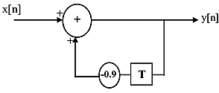

**Question 02 (CLO-02)**

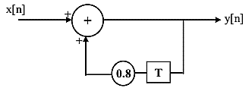Find and sketch the first few sample values of the impulse and step responses of  
the system given in figure below:

**Question 03 (CLO-02)**

Find the Circular convolution between  
x[n] = 1, 2, 3, 4 n ≥ 0  
h[n] = 4, 3, 2, 1 n ≥ 0

**Question 04 (CLO-02)**

Find the linear convolution between  
x (n) = 1, 2, 3, 4 n ≥ 0  
h (n) = 4, 3, 2, 1 n ≥ 0